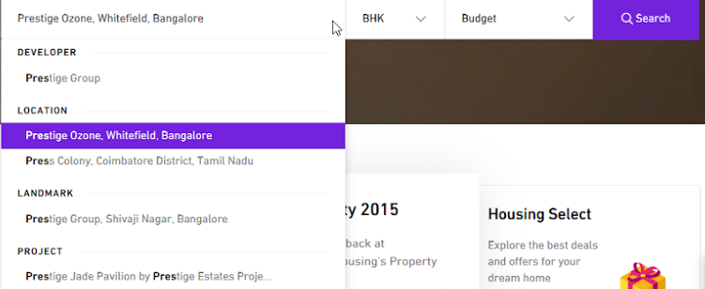

* It should display all matching string in below category:
* Institute Category (Daycare, School, College etc).
* Location
* Locality
* Landmark
* State
* By default it should use the current location. If it is open in Whitefield then Whitefield or RT nagar etc
* Reduce the length of first search bar as we see many other are overlapping
* Increase the length of those textbox given text is overlapping to next line. It should come in same line
* Change brown colour line selector to blue

**College**



Above need to reformatted as below (Use some other colour combination)



